CSCI 5010 – Fundamentals of Data Communications

Lab

Static and Dynamic Routing

University of Colorado Boulder

Department of Computer Science

Network Engineering

Professor Levi Perigo, Ph.D.

# Summary

This lab is intended to be an overview of Cisco IOS configuration, and routing technologies, such as static routes, default routes, link failover, and dynamic routing protocols.

The questions in the lab are intentionally vague. The purpose of this is for you not only to research, investigate, and learn the technologies, but also become proficient at interpreting both non-technical and technical questions. Being able to research and discover answers on your own will be critical as you progress in your career.

* Learn how to perform basic router configuration & troubleshooting including:
  + Configure static routes and populate the routing tables
  + Apply administrative distance for automatic route failover
  + Designing and configuring a routing protocol to create dynamically learned routes
  + Routing protocol convergence and failover

# Part 1

# Objective 1: Network Design and Setup [16 points] Create the following network topology, enable all the appropriate ports, and configure the basic setup for the devices in the topology.

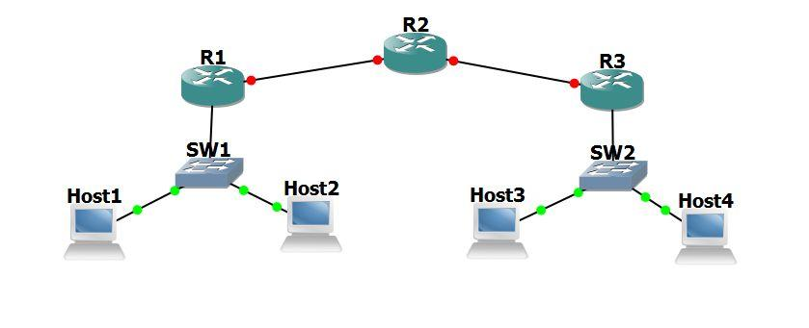

1. Use /24 subnets for all LANs (Each host is in a different subnet) (private IPv4 addresses). Other than IP and subnet, nothing else is configured on the hosts.
2. Use /30 subnets for network connecting routers (private IPv4 addresses)
3. Add your addressing scheme to the network diagram (drawing) indicating the subnets for each network, as well as the interface/PC addresses used in your design [**10 points**]

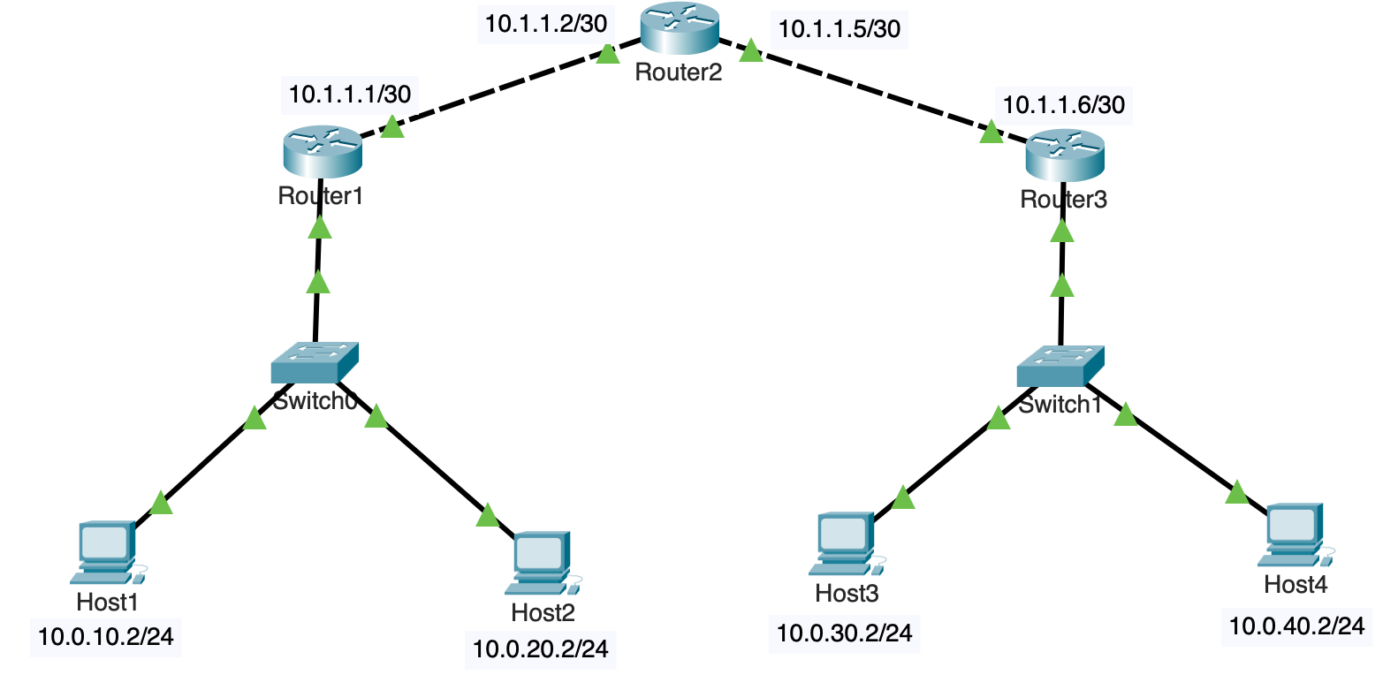

1. Make sure there is IP connectivity from each PC to the local router (ping the LAN & WAN interfaces).
2. Can PC1 ping the WAN interface IP address of R1? Why or why not? [**2 points**]

PC1 can ping the WAN interface if R1 since it is local to R1. In R1’s route table, there’s a “connected” route to 10.1.1.1/30 subnet and hence PC1 can reach 10.1.1.1/30.

Also, there’s a “local“ route to 10.1.1.1/32

1. Is PC1 able to ping R3? Why or why not? [**2 points**]

No. PC1 cannot reach R3. PC1 would send to its default gateway R1 since R3 is on a different subnet. R1 does not have a route in its route table to R3 and does not know how to reach R3, hence it will discard the packets.

1. Explain one reason why PC1 could ping the LAN IP address of R1, but could not ping the WAN IP address of R1. [**2 points**]

PC1 can ping 10.1.1.1/30 (*default gateway*) and 10.0.2.1/24 (*WAN IP of R1-R2 link on R1*) but cannot ping 10.1.1.2/30 (*WAN IP of R1-R2 link on R2*). Although 10.1.1.1/30 is in R1’s route table, PC1 cannot reach Router2’s interface IP connecting to Router1. The reason being that R1 is able to forward the traffic to R2, however, R2 does not know how to reach back to PC1 since PC1’s subnet (10.0.10.0/24) is not in its route table, hence it is unable to send ICMP response back and discards the packet. For this to work, R1 needs to advertise its Host1 and Host’2 subnets to other routers via some routing protocol so that the other routers know that to reach Host1 and Host2, they should redirect the traffic to Router1.

# Objective 2: Static Routing [14 points]

1. Configure static routes in each router to ensure connectivity between all routers and PCs in the network.
   1. Show the static routes configured
      1. Show the routes in the route table of R1 and R2 [**2 points**]

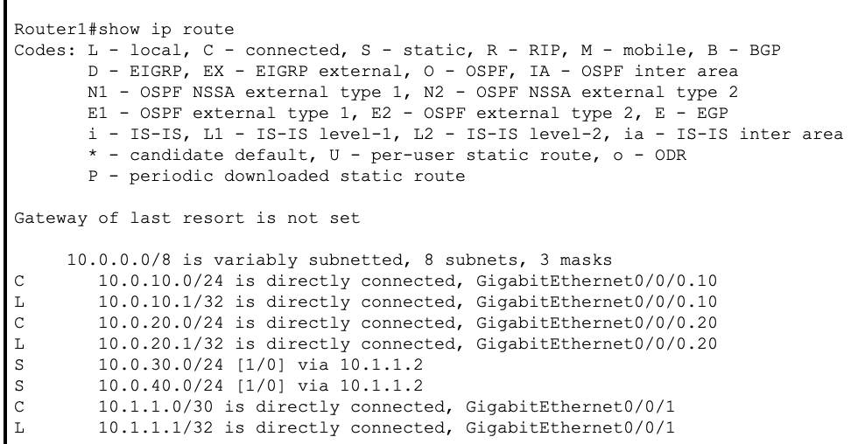

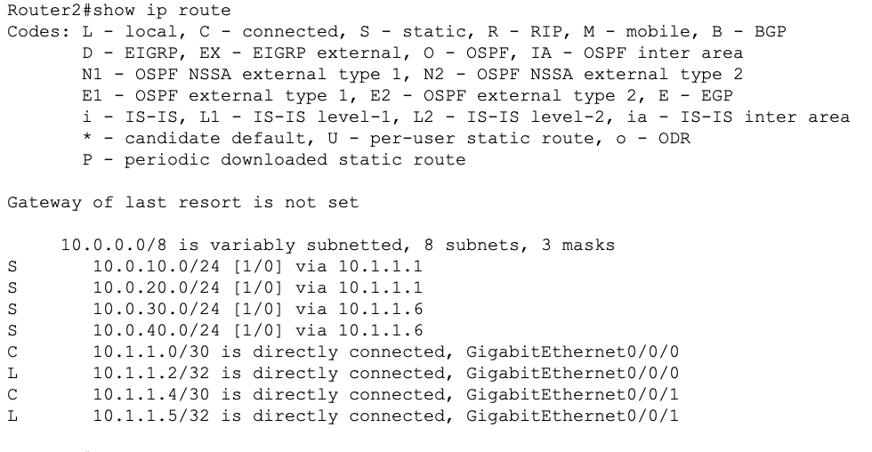

* + 1. Show the routes in the running configuration of R3 [**2 points**]

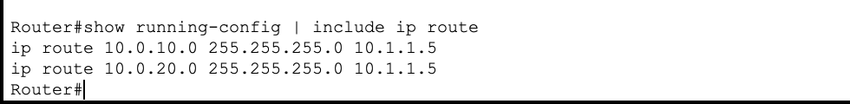

1. Configure Inter-VLAN routing, ensure and maintain 100% connectivity between all devices in the network.
   1. Provide the output from traceroutes from PC1 to PC2, 3, & 4 [**10 points**]

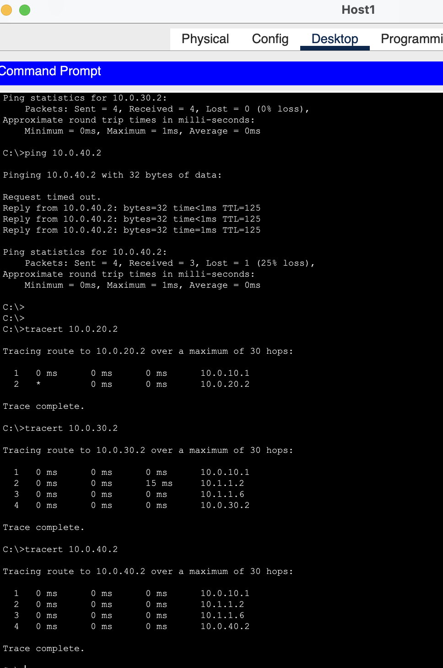

# Objective 3: Dynamic Routing (RIP or OSPF) [30 points]

Create the following network topology, enable all the appropriate ports, and configure the basic setup for the devices in the topology.

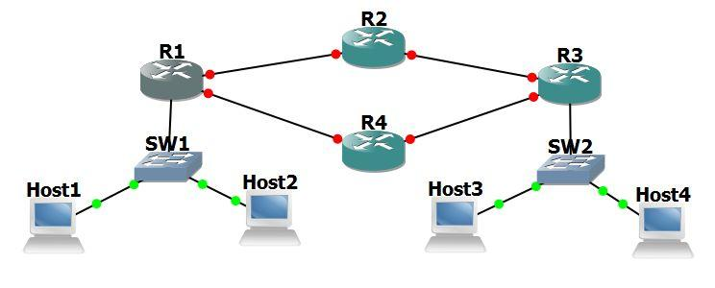

1. Remove the static routes from all router configurations.
2. Configure RIPv2 or OSPF on all router interfaces and networks.
   1. Provide commands used to implement, screenshot of the route table (from R2 & R4) indicating the network has converged [**20 points**]

Commands to configure OSPF:

router ospf 1

network <network to advertise> <wildcard mask> area <area number>

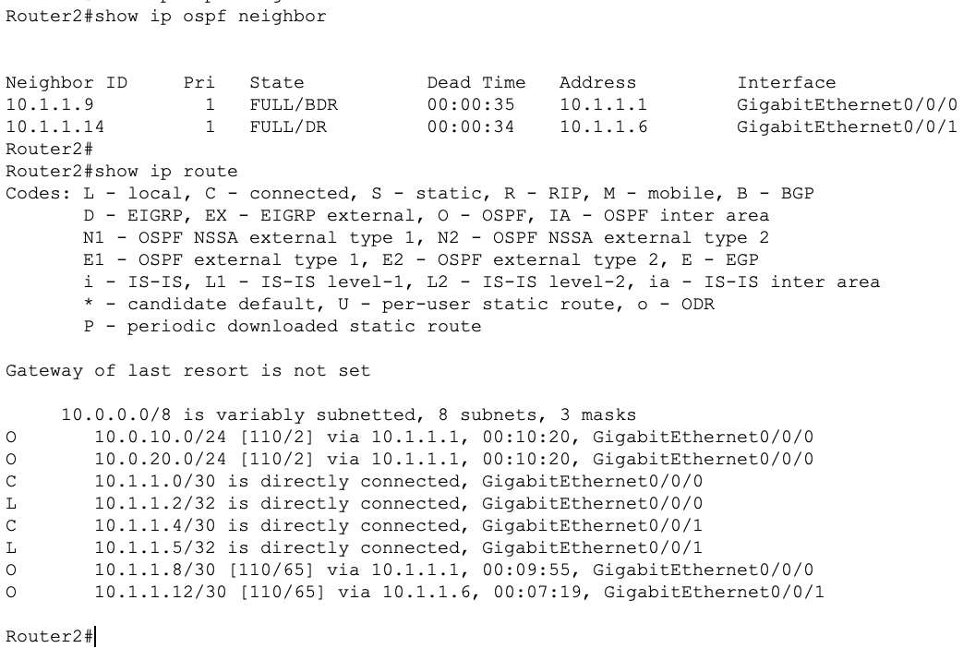

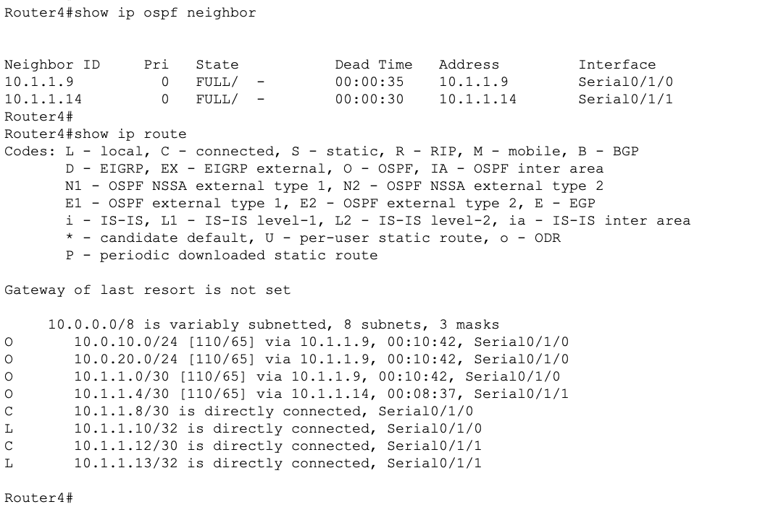

* + 1. What does convergence mean, and why is it important? [**10 points**]

When a network has converged, it means that all routers have exchanged routing information, calculated their routing tables, and determined the most efficient paths to forward data packets. Convergence ensures that routers have an accurate and consistent view of the network. This minimizes routing inconsistencies and improves network stability. It also allows routers to select the most efficient paths to destinations, optimizing network performance and minimizing latency.

Extra Credit: Implement RIPv2 as well as OSPF separately on the network and answer question for Objective 4. **[+5 points]**

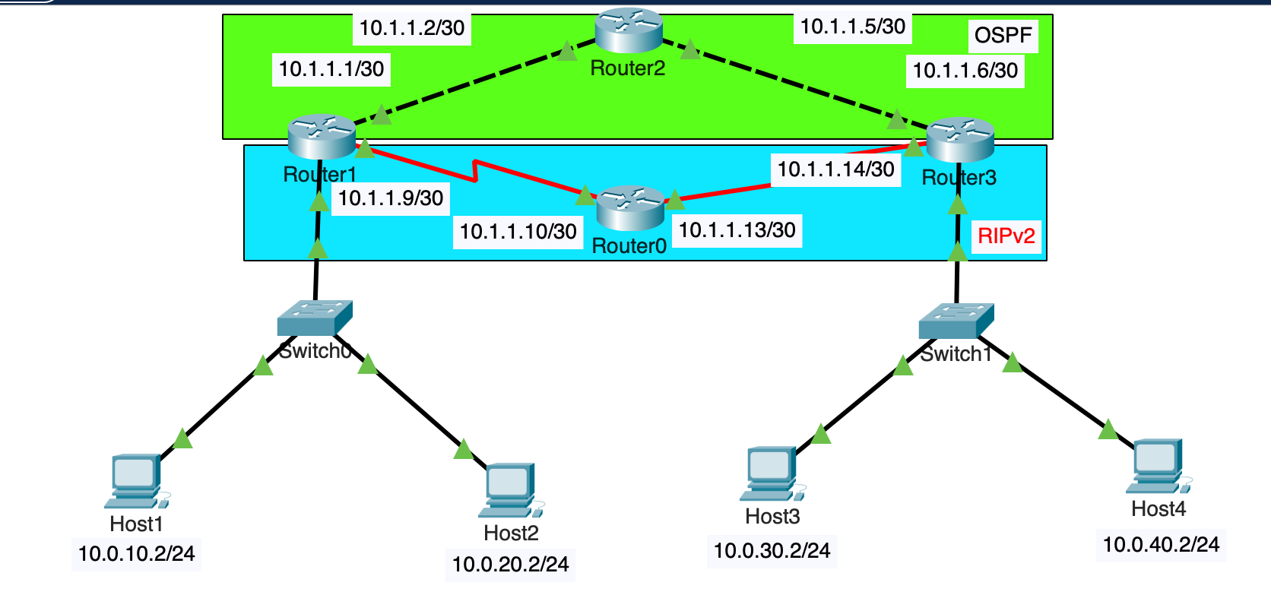

# Objective 4: Routing Protocol Failover [17 points]

1. Demonstrate Failover
   1. Issue a traceroute from PC1 to PC3. Which path is it taking? [**2 points**]

It takes the OSPF route, i.e, from PC1 -> Router 1 -> Router 2 -> Router 3 -> PC3

* 1. Issue a continuous ping from PC1 to PC3.
  2. Remove the router link/connection between the active path routers (discovered in above [1.a]). *For example, if the path was R1, R2, R3, then remove the connection to R2*. 
     1. Were any packets lost? If packets were lost, how long was the network down? Explain this, and indicate how the traffic failed over and the new traffic flow [**5 points**]

The network was down for about 2-3 seconds and lost 3 packets. Initially, since OSPF has a lower AD than RIPv2 and PC3’s subnet was being learnt by both protocols, OSPF was preferred. However, when I shut the link between R1 and R2, the path was no longer valid and R1 immediately realized that OSPF adjacency was down and failed over to the secondary link (R4).

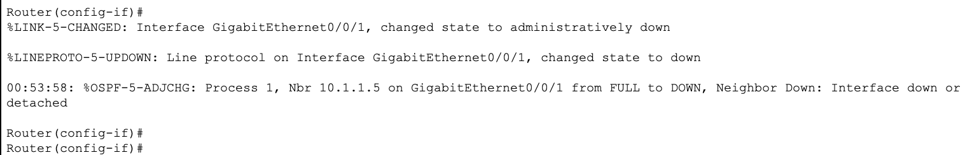

A tracert confirms that the failover was successful and takes the R4 route.

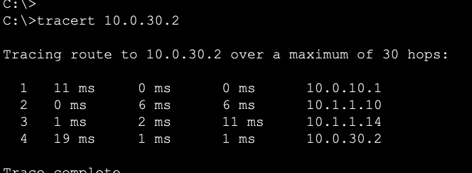

The Route table on R1 also indicates that PC3 and PC4’s subnets (10.0.30.0/24 and 10.0.40.0/24) is being learnt via RIP (R) now which was earlier being learnt by OSPF.

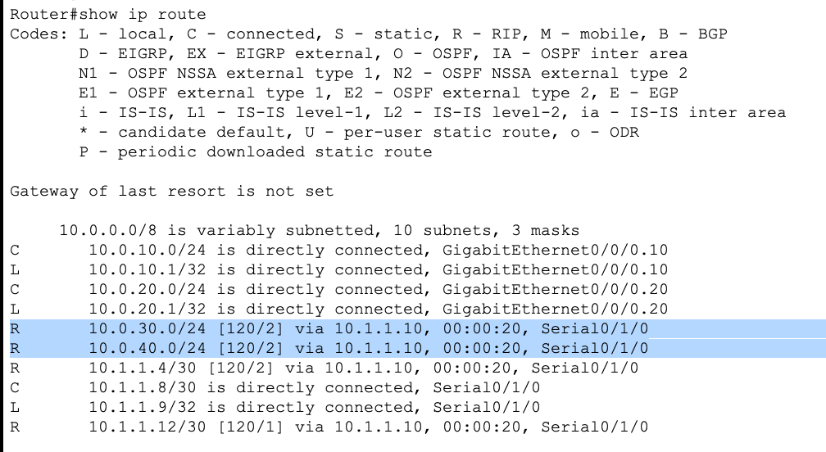

Here’s a screenshot of the ping output:

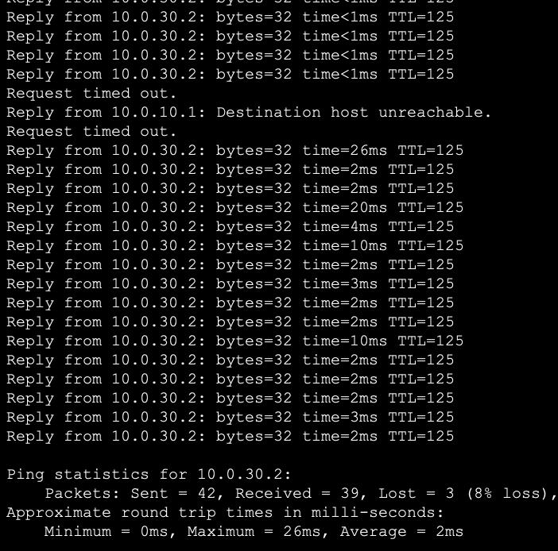

* 1. Do some critical thinking and research. Could failover be achieved with this network design using only static routes? Explain [**10 points**]

Since static routes have the same admin distance and have no metric, the traffic is load-balanced between the two links. If the destination prefix is learnt by two static routes, the traffic would be load-balanced between the two links.

The issue with static route is that if a link goes down, it has no way to determine that a link went down and it does not “unlearn” the route. Instead, the route remains the same and it still tries to load balance even when the link is down. This means that some packets would be lost and some would go through. This would lead to latency and network downtime.

**Report Questions**: [18 points]

* What are the advantages of using routing protocols?

Routing protocols enable dynamic updates of routing information in response to changes in the network topology. This ensures that routers are aware of the most current routes to destinations, making the network adaptable to changes.

Routing protocols calculate the best routes based on various metrics, such as cost, bandwidth, delay, and reliability. This automatic route selection optimizes network performance.

Routing protocols support the configuration of multiple paths to the same destination. In case of link or node failures, routers can automatically switch to alternate routes, enhancing network availability and fault tolerance.

* What is the difference between Distance Vector and Link State Routing protocols?

**Distance Vector**: Distance Vector routing protocols periodically send their routing tables to neighboring routers. These updates contain information about available routes to all known destinations. Examples: RIP and RIPv2. It is also known as “Routing by rumor” since it learns the routes from neighboring routers. Metric: Hop Count.

**Link State**: Link State routing protocols do not periodically broadcast their entire routing tables. Instead, they advertise information about the state of their links when there are changes in the network. Every router has an entire network map of the network. Examples: OSPF (Open Shortest Path First) and IS-IS (Intermediate System to Intermediate System). Metric: Cost.

* What are the advantages of using static routing or when would static routing be preferred over dynamic routing?

Static routing is straightforward and easy to configure. It doesn't involve complex algorithms or dynamic updates. Static routing can be used when traffic patterns are predictable, and the network layout rarely changes, such as in point-to-point links or simple branch offices or when small and simple networks where the routing requirements are basic or can also be used as a backup mechanism where dynamic routing is preferred more (by tweaking the AD).

* Classify the below routing protocols as Distance Vector and Link State Routing protocols:

1. OSPF, BGP, RIP, IS-IS

OSPF: Link State

BGP: Path Vector

RIP: Distance Vector

IS-IS: Link State

* Give:
* Scenario when distance vector routing protocol would be used in the network.

Distance vector routing protocol would be more suitable in smaller network with a few routers and a limited number of subnets or network segments and there are no plans for significant expansion since its resource overhead is sizeably lesser than that of Link State. It consumes lesser CPU and memory and is easy to maintain and manage.

* Scenario when link state routing protocol would be used in the network.

A Link State Routing Protocol would be more suitable in larger networks or where there’s a scope for expansion. It is typically used in more complex networks where a granular understanding of the network topology and advanced features are required. It would be used in scenarios where:

-> The network spans across multiple geographical locations.

-> There are numerous subnets or VLANs, for different purposes.

-> The network topology is complex, with multiple redundant paths.

* What is an Administrative Distance (AD) for a routing protocol? Give AD for OSPF and RIP.

Administrative Distance is a numeric value that tells how trustworthy a route is when a router learns the destination path from two different routing protocols. Lesser the AD, more the preference. OSPF AD: 110. RIP AD: 120

.

* What is a metric in a routing protocol?

A metric in a routing protocol is a numerical value that represents the "cost" or "distance" associated with a particular route to a destination network. Metrics are used by routing protocols to determine the best path or route to reach a specific destination.

# **Extra Credit Q1 - Understanding Routing Protocol [ 25 points ]**

E1.1 For the network given below in Figure. 1, give global distance-vector tables **WHEN:**

1. Each node knows only the distance of its immediate neighbors. **[4pt]**
2. Each node has reported the information it had in the preceding step to its immediate neighbors. **[4pt]**
3. Repeat step (b) one more time. **[4pt]**



Figure. 1

Refer the slides below for an example of how to do this question:

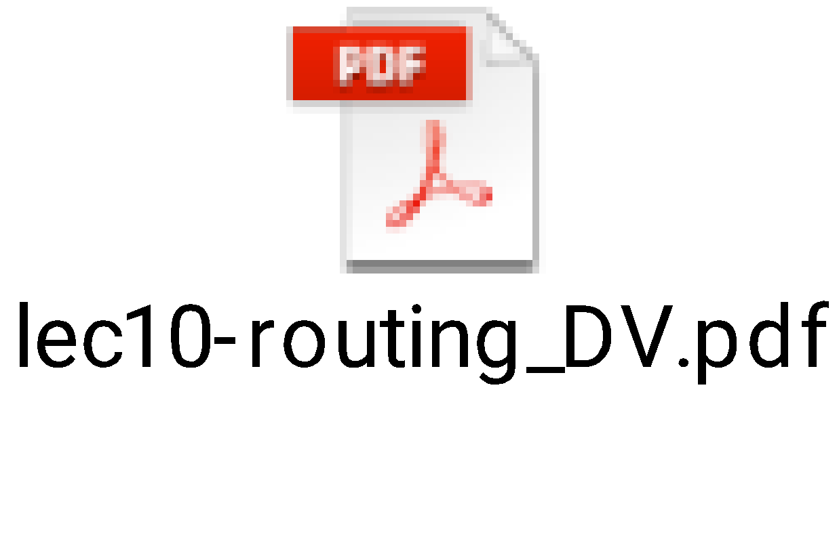

<https://www.youtube.com/watch?v=dmS1t2twFrI>

**E1.2 (7 points)**

Again for the network graph in Figure. 1. Show how the link-state algorithm builds the routing table for node D.

1. Show the detailed link-state algorithm. **[5pt]**
2. Show the final routing table of node D. **[2pt]**

Refer the slides below for an example of how to do this question:

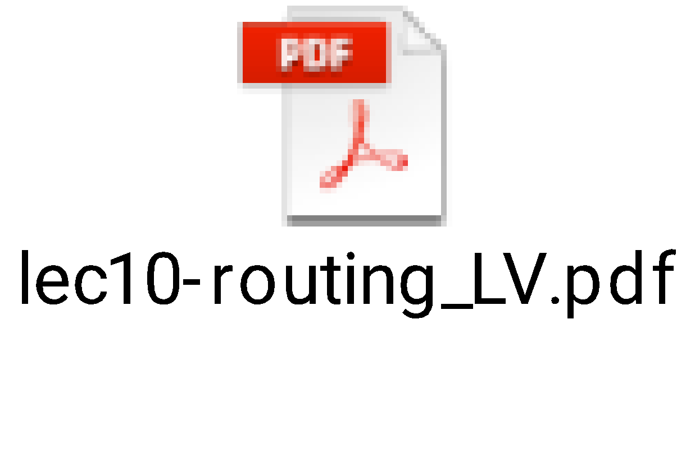

**E1.3 (6 points)**

Consider this directional graph below in Figure 4. Use Dijkstra’s algorithm to find the shortest path from node v3 to v5. Write down the **steps**. Do you have any comments on the result (what if the link cost of v3-v1 was 1 instead of 5?)? [**6 pts]**



Figure. 4

**Extra Credit Q2 [10 points]:**

Consider the above network. RIP and OSPF both are simultaneously working on this network.

For H1 to reach H3, R1 gives a RIP path R1-R2-R3 and OSPF gives R1-R4-R5-R3. Which path would packets from H1 going to H3 via R1 take?

It would choose R1-R4-R5-R3 since it talks OSPF here.

Explain why you think a particular path would be chosen.

Since H3’s subnet is being learnt on R1 by both R2 and R4, it would check the AD of the routing protocol to see which one to prefer. Since OSPF has an AD of 110 and RIP of 120, OSPF would be preferred since lower AD, higher the trustworthiness of the protocol.

Further, RIP uses hop count as its metric and OSPF uses Cost as its metric. Which means that RIP does not account bandwidth of the links to reach a destination, but number of hops to reach a destination. Whereas OSPF takes bandwidth into consideration, and sometimes, the longer path can be the faster path than the shorter path if the bandwidth is much higher on the longer path.

# Total Score = ________________/135 (including 40 extra points)